Airflow - CUP
Apache Airflow, a popular open source framework for authoring, scheduling, and monitoring multi-stage workflows. With this integration, multiple Amazon SageMaker operators are available with Airflow, including model training, hyperparameter tuning, model deployment, and batch transform.
This allows you to use the same orchestration tool to manage ML workflows with tasks running on Amazon SageMaker

ML workflow diagram:

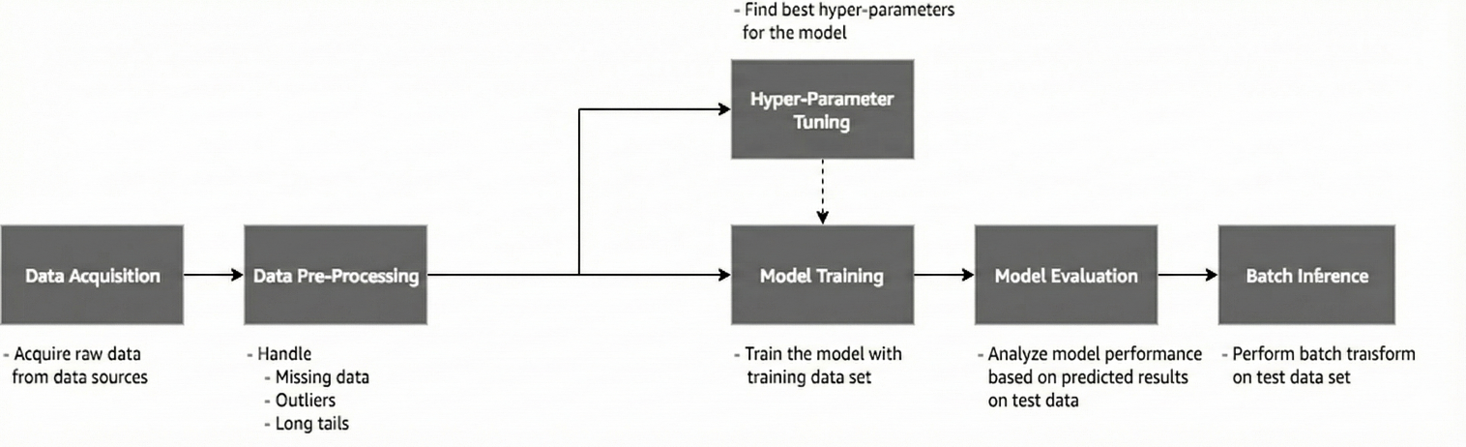

- Data pre-processing: Extract and pre-process data from Amazon S3 to prepare the training data.
- Training the model:Train the Amazon SageMaker machine model with the training data and generate model artifacts. The training job will be launched by the Airflow Amazon SageMaker operator.
- Tune the model hyperparameters: A conditional/optional task to tune the hyperparameters to find the best model. The hyperparameter tuning job will be launched by the Amazon SageMaker Airflow operator.

Airflow concepts and setup

- DAG (Directed Acyclic Graph): DAGs describe how to run a workflow by defining the pipeline in Python, that is configuration as code. Pipelines are designed as a directed acyclic graph by dividing a pipeline into tasks that can be executed independently. Then these tasks are combined logically as a graph.
- Operators: Operators are atomic components in a DAG describing a single task in the pipeline. They determine what gets done in that task when a DAG runs. Airflow provides operators for common tasks. It is extensible, so you can define custom operators. Airflow Amazon SageMaker operators are one of these custom operators contributed by AWS to integrate Airflow with Amazon SageMaker.
- Task: After an operator is instantiated, it’s referred to as a “task.”
- Task instance: A task instance represents a specific run of a task characterized by a DAG, a task, and a point in time.

Airflow architecture

- Scheduler: The scheduler is a persistent service that monitors DAGs and tasks, and triggers the task instances whose dependencies have been met. The scheduler is responsible for invoking the executor defined in the Airflow configuration.

- Executor: Executors are the mechanism by which task instances get to run. Airflow by default provides different types of executors and you can define custom executors, such as a Kubernetes executor.

- Broker: The broker queues the messages (task requests to be executed) and acts as a communicator between the executor and the workers.
- Workers: The actual nodes where tasks are executed and that return the result of the task.
- Web server: A web server to render the Airflow UI.
- Configuration file: Configure settings such as executor to use, airflow metadata database connections, DAG, and repository location. You can also define concurrency and parallelism limits, etc.

- Metadata database: Database to store all the metadata related to the DAGS, DAG runs, tasks, variables, and connections.
Airflow Amazon SageMaker operators
Amazon SageMaker operators are custom operators available with Airflow installation allowing Airflow to talk to Amazon SageMaker and perform the following ML tasks:
- SageMakerTrainingOperator: Creates an Amazon SageMaker training job.
- SageMakerTuningOperator: Creates an AmazonSageMaker hyperparameter tuning job.
- SageMakerTransformOperator: Creates an Amazon SageMaker batch transform job.
- SageMakerModelOperator: Creates an Amazon SageMaker model.
- SageMakerEndpointConfigOperator: Creates an Amazon SageMaker endpoint config.
- SageMakerEndpointOperator: Creates an Amazon SageMaker endpoint to make inference calls.

Airflow setup:
MWAA Environment - amp-hu-sbx-mwaa-env
Environment Class: mw1.small (Supports horizontal scaling for workers (1–10))
The permissions granted across various AWS services
AWS Service | Key Allowed Actions | Scope of Resources
Amazon S3 | ListBucket, GetObject, PutObject, DeleteObject | Specific raw, artifact, MWAA, and metadata buckets.
Amazon SageMaker | CreateProcessingJob, DescribeProcessingJob, etc. | All processing jobs in your account/region.
AWS IAM | PassRole | One specific SageMaker execution role.
Amazon CloudWatch Logs | CreateLogGroup, PutLogEvents, DescribeLogGroups, etc. | Specific Airflow & SageMaker log groups; some wildcards (*).
Amazon DynamoDB | Full table operations (PutItem, Query, DeleteItem, etc.) | Two specific DynamoDB tables.
Amazon CloudWatch | PutMetricData | Unrestricted (*).
Amazon SQS | Core queue operations (SendMessage, ReceiveMessage) | Specific Airflow Celery queues.
AWS KMS | Decrypt, Encrypt, GenerateDataKey | Keys accessed via SQS, excluding your account's keys.

AWS Resources Required:

Resource | Purpose | Names
MWAA Environment | Airflow execution environment | amp-hu-sbx-mwaa-env
S3 Bucket (Primary) | DAG code and schema storage | yettel-hu-sbx-ml-mwaa-s3-bucket
DynamoDB Table 1 | Model metadata storage | sbx-mlops-experiment-ddb-table
S3 Bucket (Artifact) | Model artifacts and fallback storage | yettel-hu-sbx-ml-artifact-s3-bucket
Set Airflow Variables:
AWS_REGION = eu-central-1
DDB_TABLE_NAME = sbx-mlops-experiment-ddb-table
ENVIRONMENT = sbx
Sagemaker_Execution_Role = "arn:aws:iam::463470953539:role/service-role/AmazonSageMaker-ExecutionRole-20251013T202936"
Running the Pipeline
Trigger: Navigate to Airflow UI → DAGs → Trigger DAG
S3 Buckets
mwaa_bucket = "yettel-hu-sbx-ml-mwaa-s3-bucket"
raw_data_bucket = "yettel-hu-sbx-ml-raw-s3-bucket"
artifact_bucket = "yettel-hu-sbx-ml-artifact-s3-bucket"
processed_bucket = "yettel-hu-sbx-ml-processed-s3-bucket"
MWAA Bucket Directory Structure:
s3://yettel-hu-sbx-ml-mwaa-s3-bucket/
│
├── dags/
│ ├── master_dag.py
│ ├── prprocessing_dag.py
│ ├── model_training_dag.py
│ ├── hyperprameter_dag.py
│
├── cup/
│ ├── model_metadata/
│ │ ├── metadata.json
│ │ └── ...
│ ├── sagemaker_preprocessing/
│ │ ├── preprocessing_script.py
│ │ └── ...
│ ├── sagemaker_model_training/
│ │ ├── training_script.py
│ │ └── ...
│ ├── sagemaker_hyperparameter_job/
│ │ ├── hyperparameter_tuning.py
│ │ └── ...

Building a machine learning workflow :
we’ll create a ML workflow using Airflow operators, including Amazon SageMaker operators to build the use case Card Unit Prediction.
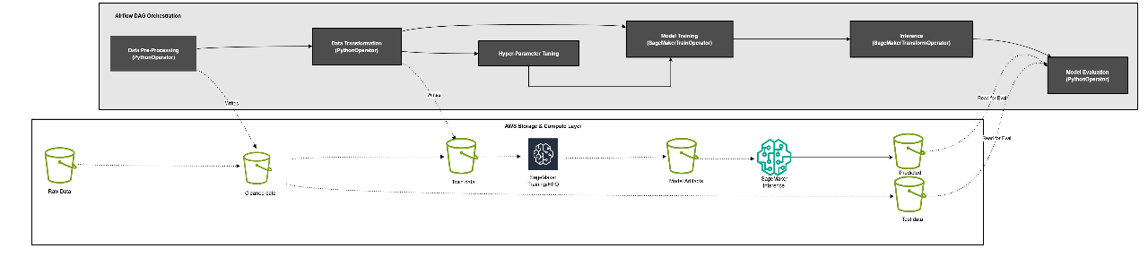
The pipeline ingests raw data from the raw bucket, applies configurable preprocessing (missing value, splits, schema checks), launches hyperparameter tuning for candidate models, runs forecasting (e.g., GreyKite), and persists artifacts/metrics to the storage bucket with consolidated metadata in DynamoDB.

Graykite Model :
The Models Are Ephemeral (Designed for a Single Use)
The primary goal of this system is to answer one question daily: "What is our predicted total activation, churn, and netgain for the current month, as of today?"
The model trained on a given day (run_date) is highly specific to that point in time. Its entire purpose is to forecast the remaining days of the current month. By the next day, the "current month" hasn't changed, but you have one more day of actual data. Retraining on this new data point will produce a forecast for the remaining days.
Train: Pull the last N months of data (e.g., 24 months).
Score: Use that freshly-trained model to predict until the end of the current month.
Discard: Throw the model away. The only artifact that matters is the prediction value written to the database.
Repeat: Do it all again tomorrow.

This approach avoids numerous complexities:
  - Model Versioning: No need to manage thousands of model files (1 file per subsegment per target per day would be millions of files a year).
  - Model Drift: They don't have to worry about a model becoming stale because a new one is built every day from the most recent data.
  - Data Dependency Management: They don't have to store the exact snapshot of data used to train a historical model. The database always has the canonical source of truth.

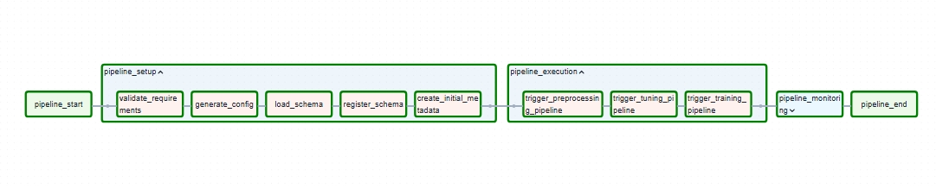

DAG:
- Data Preprocessing DAG: The dataset contains dummy card unit values.
The data tracks three main movements of customers:
  - Incoming (Growth):

    - Activation: New cards or accounts being started.
    - Rejoin: Old customers coming back.
  - Current Status (Volume):
    - Cardunit: The total number of active cards or units currently in existence.
  - Outgoing (Loss):
    - Churn & Termination: Customers cancelling or closing their accounts.
    - Lost: Likely refers to lost physical cards or accounts that vanished for other reasons.

Columns: dayid ,subsegid (Segment ID),subsegdesc (Segment Description),activation, cardunit,rejoin,lost,termination,churn.

  - S3-based data loading from parquet files
  - Data cleaning and quality validation
  - Processing data for time series modelling
  - Store this cleansed data in an S3 bucket for the next task to pick up and process.

GIT CODE- cloud / aws / analytics / mlops / cup-poc · GitLab

- Model training and tuning DAG: train and tune the algorithm by launching a training job using Airflow Amazon SageMaker Operators.
  - Use SageMakerTuningOperator to run a hyperparameter tuning job to find the best lookback month by running many jobs that test a range of hyperparameters dataset

Hyperparameter Tuning :
- Cross-validation for lookback period optimization
- Multiple evaluation metrics support
- Parallel tuning across target-subsegment combinations

GIT CODE - cloud / aws / analytics / mlops / cup-poc · GitLab

  - Use SageMakerTrainingOperator to run a training job by setting the hyperparameters known to work for data.

Model Training :
- Greykite/Silverkite model implementation
- Automated model training and evaluation
- Parallel training across target-subsegment combinations

GIT CODE- cloud / aws / analytics / mlops / cup-poc · GitLab
Putting it all together
Airflow DAG integrates all the tasks we’ve described as a ML workflow. Airflow DAG is a Python script where you express individual tasks with Airflow operators, set task dependencies, and associate the tasks to the DAG to run on demand or at a scheduled interval. The Airflow DAG script is divided into following sections.
- Set DAG with parameters such as schedule interval, concurrency, etc.
dag = DAG(
dag_id='sagemaker-ml-pipeline',
default_args=args,
schedule_interval=None,
concurrency=1,
max_active_runs=1,
The schedule interval tells the system exactly when to repeat the list.
Concurrency limits how many tasks are allowed to happen at the same time.

- Set up training, tuning, and inference configurations for each operator

After the DAG is ready, deploy it to the Airflow DAG repository using CI/CD pipelines/Manual

GIT CODE - cloud / aws / analytics / mlops / cup-poc · GitLab

Limitations
- MVP Scope: Current implementation is limited to the Minimum Viable Product.
- SageMaker Estimator Usage: The solution currently relies on SageMaker Estimator.
- Container-Based Approach: Migration to containerized architecture is required.
- DAG Optimization: Existing DAG scripts need performance and efficiency improvements.
- CI/CD Pipeline: A robust CI/CD pipeline needs to be implemented.
- AWS Script Management: Integration with AWS Script Manager is necessary

